Task 4: C++ OOP & STL Mini Application
Overview
Development of a Library Management System using Object-Oriented Programming concepts and STL containers.
Objective
- Design a mini application using classes and objects.
- Apply OOP concepts such as encapsulation and abstraction.
- Use STL containers for efficient data management.
- Implement file handling for data persistence.
- Develop a modular and maintainable C++ application.
Tools Used
- GCC/G++
- Makefile
- Linux/Windows Terminal
Algorithm / Design
- Book Class: Represents book details such as ID and title.
- Library Class: Manages the collection of books using STL containers.
- Add Book: Inserts new book records into the system.
- Display Books: Retrieves and displays all stored book information.
- File Handling: Saves and loads book records from a text file to maintain data persistence.
Complexity Analysis
Time Complexity
- Add Book: O(1)
- Search Book: O(n)
- Display Books: O(n)

Space Complexity
- O(n)
Sample Input
1 C++
2 DSA
Sample Output
Book ID: 1 Title: C++
Book ID: 2 Title: DSA
Data saved successfully.
Screenshots
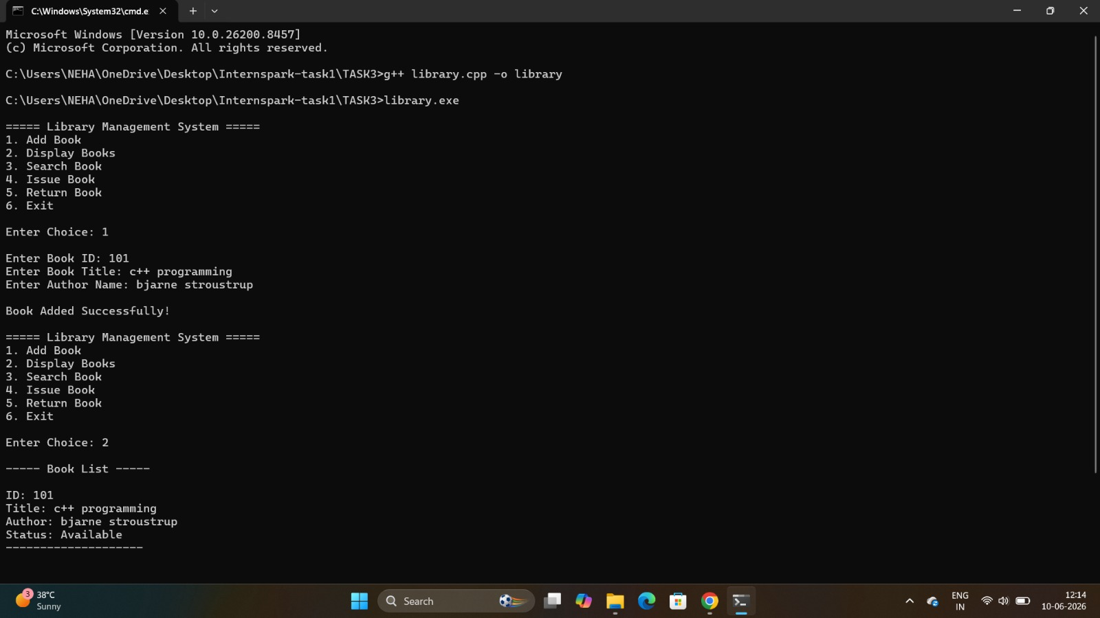
Conclusion
The Library Management System was successfully developed using C++ and STL. The project provided practical experience in applying OOP principles, file handling, and container-based data management.

